Uganda Report 2019

Yet again I have returned safely from Uganda, where, yet again, I had a busy but very fruitful time.
So, we all arrived in Nairobi, Kenya, where we spent the first 2 days on a Teaching the Teachers training course with PRiME https://www.prime-international.org/home.htm Godfrey found this training very useful because he has been teaching Whole Person Healthcare in Kasese but has never actually been on a PRiME course due to the fact that his visa to come to the UK for the PRiME conference this year was declined. I could see his brain whirring as he worked out how he could apply this new information to his teaching.

We then spent the next 3 days at the Global Mission Conference in Nairobi, who’s theme for this year was Pursuing Holistic Impact! We found that mission work appears to have moved from supporting big organisations to supporting small indigenous grassroots projects, which was hugely encouraging because this is exactly what we are. We gave a presentation on ‘Whole Prison Care’ to around 30 people, Godfrey told his story of when he was wrongly imprisoned and how CHALAPI was formed https://www.chalapi.com and how they have been making a difference in Kasese. Many were moved both by the story and his work since then, and took his contact details. Over 200 people attended the conference and Godfrey was able to connect with some significant people who we hope will be able to encourage and support him in his work.

From Nairobi we travelled to Kampala, where we met up with Carol who had flown out from the UK. Godfrey travelled home to Kasese ahead of us. Carol and I stayed at our dear friend Betty’s home, with her lovely, happy, generous family and we all visited our sponsored daughter Rachel at her new school for disabled young people, where she is learning sewing and tailoring for one year, in order to give her a skill to use. Rachel is Head Girl of the school, has blossomed from a shy girl into a beautiful, confident young woman and it was a joy to see her. Carol’s colleague Richard, a technician who she works with at Kagando Hospital came to see Rachel with a new wheelchair for her, fitted to her size and shape. We also took a big cake which was shared between all the students and staff at the school. We don’t think anyone has done this before so it went down a storm and we were encouraged to return next time we are in Uganda!
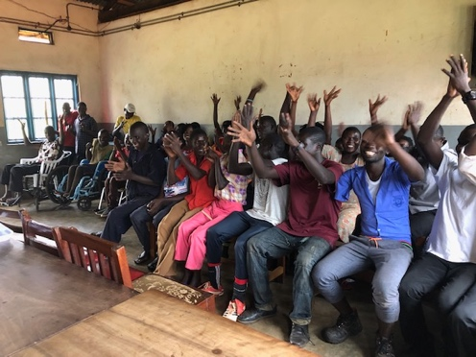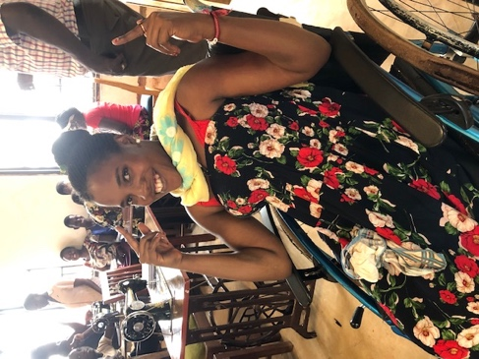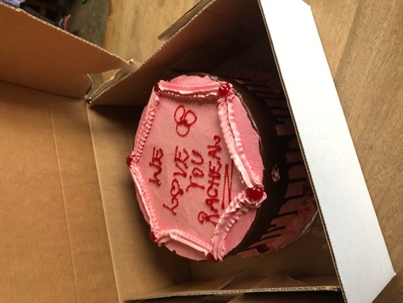
Young people at Rachel’s school Rachel now! The Cake

We made the long drive across Uganda to Kasese after 4 days in Kampala, and the day after arriving we visited the Church under the Tree, where I was able to give some money donated to me by my church. They immediately went out and bought 20 plastic chairs, as their congregation is growing and they needed more. The 20 chairs arrived on a boda boda and everyone was overjoyed. They send their warmest greetings to all at Herstmonceux Free Church (it was funny hearing them try to say Herstmonceux!). We then went to paint the Health Centre at Kasese Police Barracks, which was in dire need. A policeman passing by said it ‘is now fit for human beings’, which made us both happy and a bit sad.

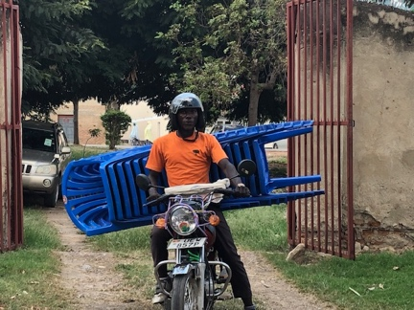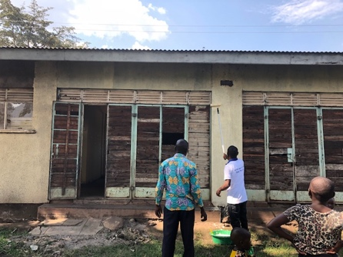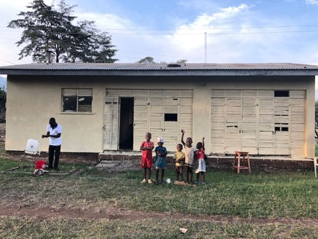
Chairs arriving on boda boda Before painting After painting

After the weekend of visiting friends, attending a chaotic celebration for the street children of Kasese and preparing for the following week, Carol moved to Kagando Hospital to start her work there. Godfrey and I then started 2 days of training in Whole Person Healthcare for 45 pastors, nurses and community leaders, in a remote mountain town called Rwesande, in a church with no electricity. (We travelled there by car, not boda boda this time) We were training mainly older men and I sensed some resistance from them as we started. However, the engaging and informal style of the PRiME teaching soon had them joining in with enthusiasm and feedback was overwhelmingly positive, with comments like ‘I will not remain the same’, ‘I will not discriminate (because) patients are human beings’ (!), ‘I will make sermons (on) .. matters relating to personal hygiene’(!!) and ‘to be honest I loved everything’.

I was told that since we did similar training in another village last year, hand washing stations have been set up outside toilets in the surrounding villages and the Champions that we taught have been teaching people the importance of hand washing – soap is cheaper than medicine! Godfrey says that the incidence of diarrhoea and vomiting has dropped dramatically and the have been NO cases of cholera in the last year, when usually there would have been a few outbreaks. He says Public Health Officials have noticed the improvement in health. We were hugely encouraged by this and are hoping that the training this year will have the same impact. Godfrey also says that since our training at Mubuku Prison in 2017 the incidence of diarrhoea and vomiting has also dropped because they are now washing hands, boiling water and making soap too, which is also very encouraging.

Later that week we did a PRiME Whole Person Medicine ‘taster’ session for over 200 nurses at the Kasese School of Nursing and Midwifery. They enjoyed it so much that they invited us back to do a full day of training the following week. Unfortunately, when we did only 16 student nurses turned up, but they were very good and the feedback was the best we’ve ever had. Quality was definitely better than quantity, and we were able to encourage them to be good role models in the future. We hope to return next year to teach more students, with their tutors too, as nursing care in Uganda has deteriorated with local people telling me the nurses now have very little compassion sadly.

A couple of days later we repeated the Whole Person training in another village called Rwesororo, where we had 35 VHTs, pastors and “chairmen’, or community leaders. Again, it was well received with good humoured participation and comments like ‘this is very timely’ and ‘we really needed this training’ with promises to engage their communities more. Feedback included ‘I am going to help people who are dying’, ‘I am going to teach handwashing’ and ‘I am going to visit the youth who take drugs and encourage them to save money’!

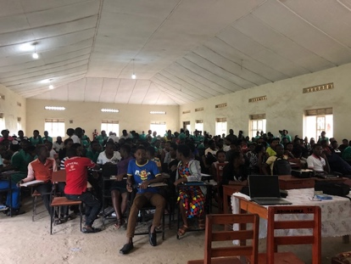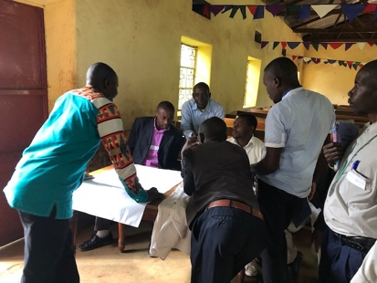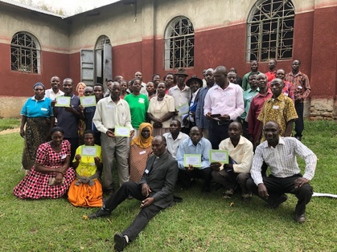
200 student nurses Training at Rwesande Certificates at Rwesororo
Later in the week we visited Katwe Prison (no photos allowed in prisons I’m afraid), in a remote part of the Queen Elizabeth National Park, where we went last year. This is a prison designed for 30 but had 118 in it that day, many of whom were arrested for illegally entering Uganda from the Congo, just across the lake. The Officer in Charge is a great guy who cares deeply about his prisoners, seeing them as members of someone’s family rather than a prisoner. One of his big concerns is that when their water goes off they have to go to the lake to collect it, and there are hungry crocodiles there! They took a cow last week and the OC said ‘how can I explain to someone’s family that they have been eaten by a crocodile?’ – not a problem we usually have in the UK! However, he has made big improvements to the prison, making bricks and selling them to build a new office to replace the office under the tree where the elephants roam at night… He has plans to put a toilet in the cell too, so the inmates can use it at night instead of a bucket. Conditions really are terrible still though, and we gave them some money to help pay for glass and mesh at the windows of the cell to keep the mosquitos out at night. The squashed remains decorated the walls of the cells…

Other things that we did include visiting various groups of people who have benefitted from receiving a sewing machine, one of which is at Noah’s Ark Primary School in the mountains where prisoner’s children attend because of low fees. The children sang and danced for us and Carol and I had to ‘shake our bodies’ with them, which had them howling with laughter. The children are being taught sewing with the machine. This is in the Pig Project area too, and a grandmother told us how having a breeding pig has meant she can now pay school fees for all the orphaned grandchildren that she cares for, and had really improved their standard of living. Thank you again to all those who donated a pig, the project is going from strength to strength with more people now benefitting as more pigs are being born and being given out to more needy families.

We also visited Rusesi Prison, where another sewing machine is located, again with some success although the prisoner who was teaching the other prisoners how to use it was released last week!

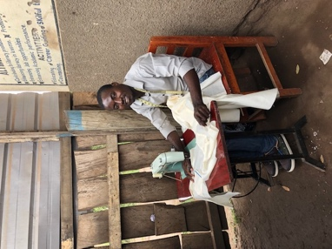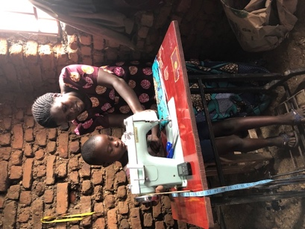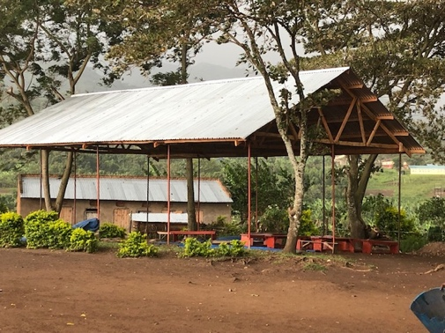
Sewing machine at Child being taught at The new Chapel
Rwenzori Royal school Noah’s Ark School

On our last day in Kasese we went on the medical outreach to Nyabirongo Prison, which has now been running for 4 years, with a report of big improvements in prisoner’s health. It was wonderful to see nurses Robert and Mollin who were in direct contact with the child who died of Ebola in June, and had to endure 21 days of quarantine before being given the all clear for themselves. They saved many lives because of their swift action in identifying the virus and getting it isolated – his mother had not been truthful about the history of the illness and the child was actually on his way to a packed children’s ward when they realised. Mollin is pregnant and had to have the still experimental vaccination against ebola when she was at 18 weeks. Her baby is due in 5 weeks’ time and has been healthy so far but she is very worried about the birth. She is being monitored by the vaccination team.

Because of the kind donation from my Church we were able to start the construction of a Chapel at the prison too. At our visit there were poles supporting a wooden frame and iron sheet roof, and when the rainy season has finished the prisoners will make bricks to finish the construction. We were able to hold a service in it and the Kagando Chaplains commissioned it before a huge storm came in and it nearly blew away! Thankfully it survived and the prisoners are very happy to have a Chapel, which can also be used as an extra room to spend time in and receive visitors as currently they only have a horribly dingy cell. We hope the local community will come to worship on Sundays too, so that the prisoners can be in more contact with the outside world, which is good for their rehabilitation.

The following day Carol and I travelled safely back to Entebbe for one night before flying back home. This was a long trip for me, but very fruitful and we look forward to returning again next year. THANK YOU all so very much for supporting this work.

